20521824 Phạm Hà Minh Quyên

Link: https://github.com/MinhQuyennn/lab4

Basic React – Exercise 1.1 – Fetching data

Basic React – Exercise 1.2 – Create spinner fallbacks

Basic React – Exercise 1.3 – React Route

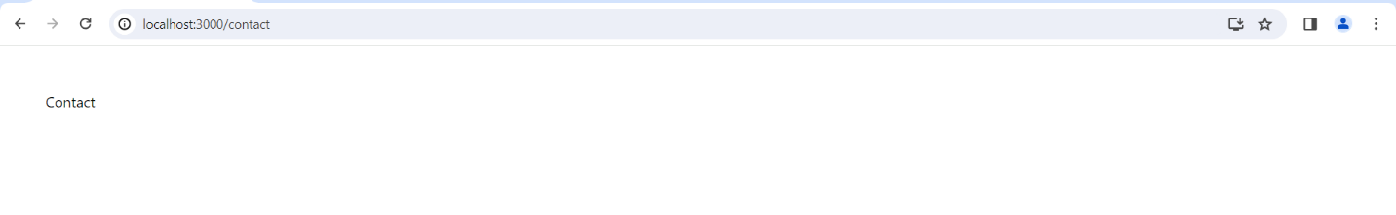

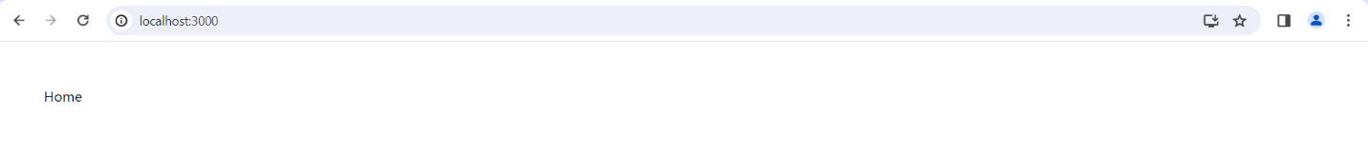

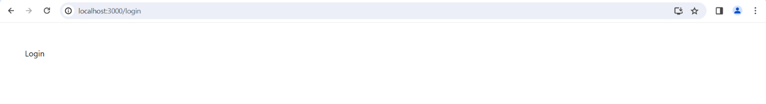

Basic React – Exercise 1.3 – Navigation components

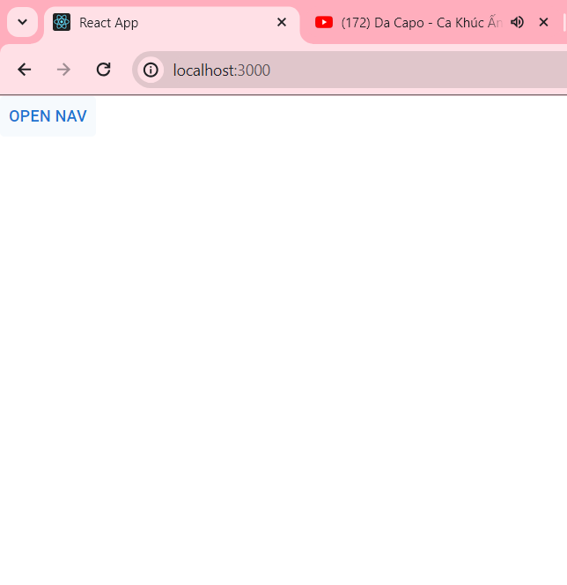

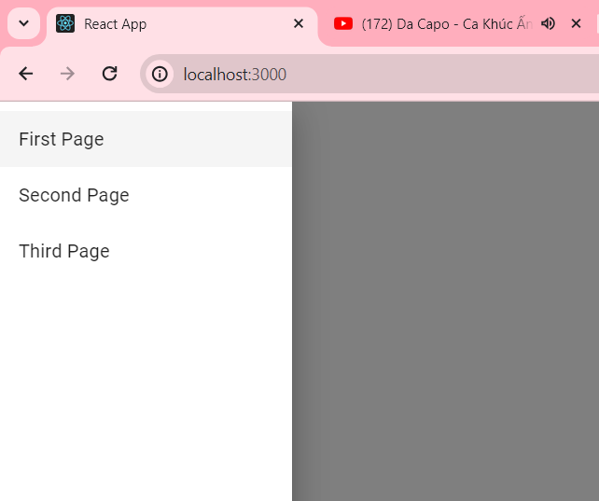

Basic React – Exercise 1.3.1 – Navigation with tabs

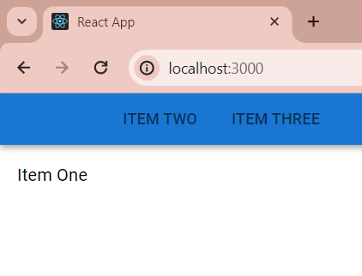

Basic React – Exercise 1.3.2 – More navigations

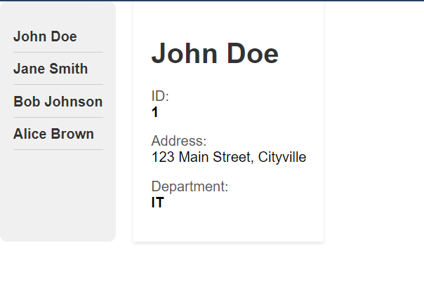

Basic React – Exercise 1.4 – Text input

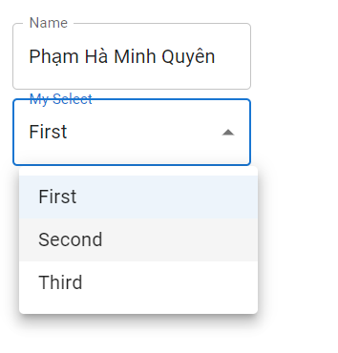

Basic React – Exercise 1.5 – Button

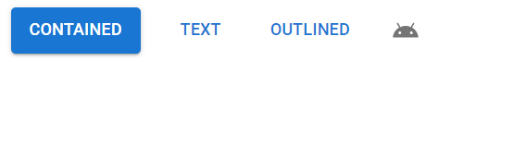

Basic React – Exercise 1.6 – Validate form

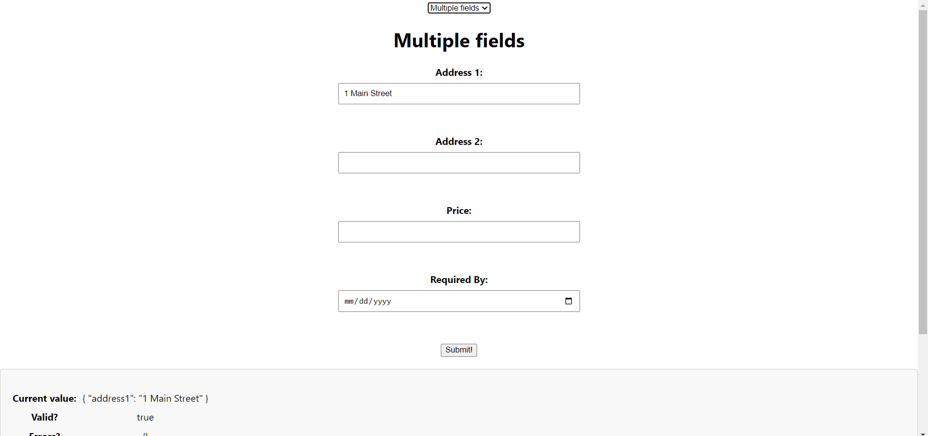

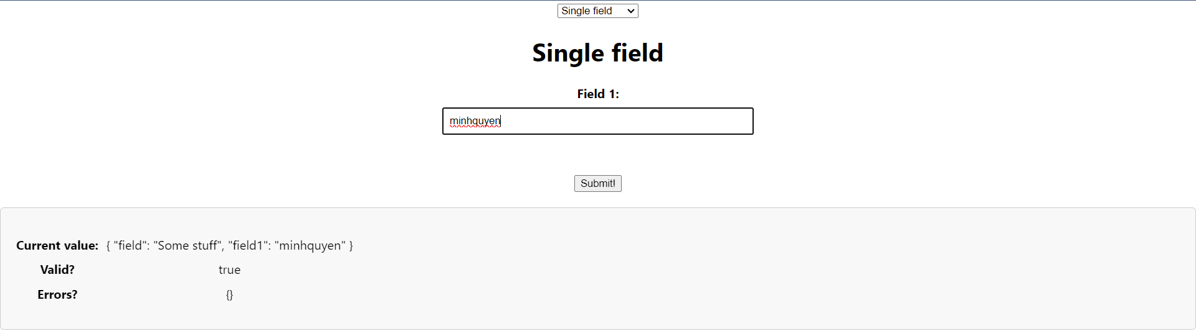

Basic React – Exercise 1.7 – API

React – Homework

